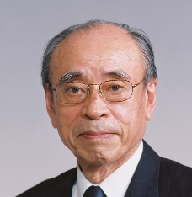
Yasuharu Suematsu received his B.E., and Dr. of Engineering degrees from the Tokyo Institute of Technology in 1955, and 1960, respectively. In 1960, he joined the Tokyo Institute of Technology and became Professor in 1973. From 1989 to 1993, he was the President of the Tokyo Institute of Technology. Since then, he has been Director-General of a national institute at MITI, President of Kochi University of Technology, and Director-General of the National Institute of Informatics (NII). He is Honorary Professor at the Tokyo Institute of Technology, and chairperson of the Kenjiro Takyanagai Foundation and the Hoso Bunka Foundation. He had served the government as a member of councils and committees. He is a Foreign Member of the National Academy of Engineering (NAE), Foreign Member of the National Engineering Academy of Korea, and Life Fellow of IEEE. His research covers high-capacity and long-distance optical fiber communications, especially semiconductor lasers and photonic integrated circuits. He was honored with IEEE Quantum Electronics Award in 1982; Valdemar Paulsen's Gold Medal, Danmark, in 1983; Electronics Letters Premium Award, IEE, UK, in 1985, David Sarnoff Award in 1986; Toray Science and Technology Prize in 1989; John Tyndal Award in1993; C&C Prize in 1994; Eduard Rhein Prize, Germany, in 1996; IEEE James H. Mulligan, Jr. Education Medal in 2003; Japan Prize in 2014; and Order of Culture from Emperor of Japan in 2015.

