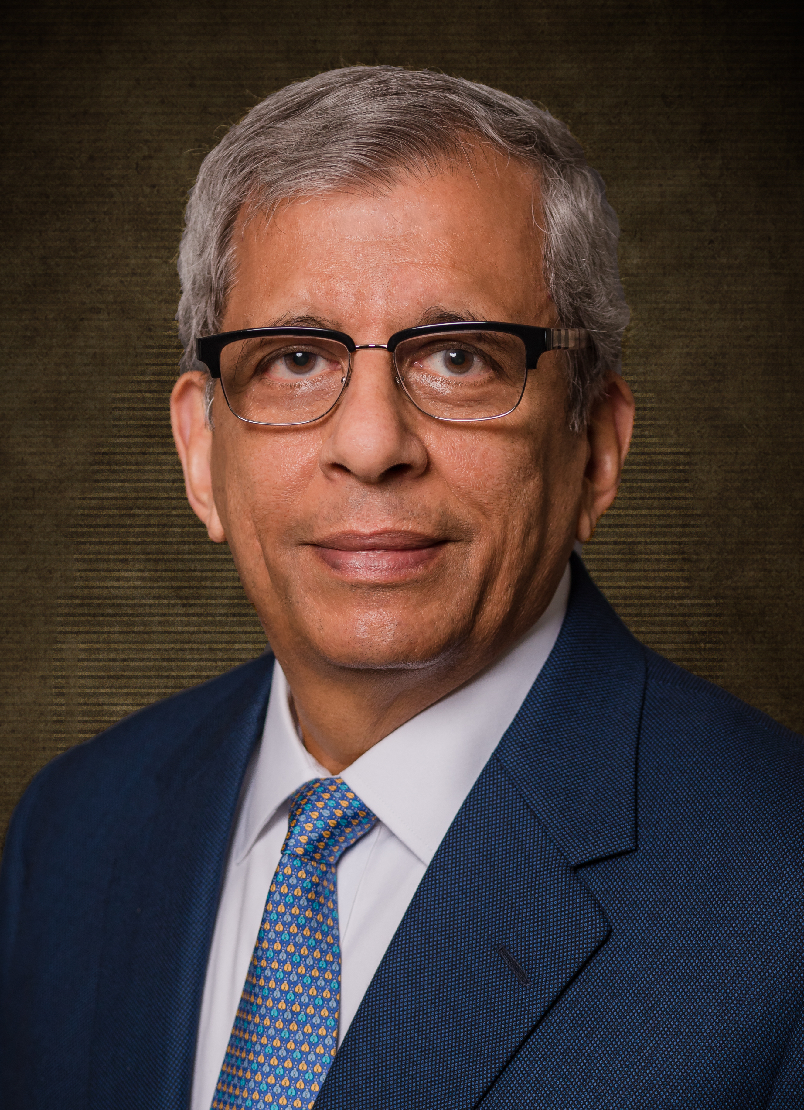

Dr. Waguih S. Ishak
Division Vice President & Chief Technologist
Corning Research & Development Corporation
Dr. Waguih Ishak joined Corning in 2007 to establish a new Silicon Valley facility, the Corning West Technology Center (CWTC) in Palo Alto, California. CWTC was chartered to build strong relationships with high-tech industries and academia in Silicon Valley and grew to include scientists and engineers working on high-speed interconnects, novel displays, and embedded sensors. The Center moved to Sunnyvale in 2017 and is now called Corning Technology Center – Silicon Valley (CTC-SV).
In May 2016, Ishak was appointed Division VP & Chief Technologist, responsible for strategic connections to Silicon Valley hotspots, VCs, startups and academia. From 2007 to May 2016 Ishak was the Division VP of Science & Technology and also the Director of CWTC. From 2005 to 2007, Ishak was the Chief Technology Officer and Vice President of Avago Technologies (Now Broadcom). From 2003 to 2005, Ishak was the Vice President and Director of the Photonics & Electronics Research Lab at Agilent Labs responsible for R&D programs in photonics, high-speed electronics, sensors, semiconductor tests, wireless communications and consumer electronics. From 1987 to 2003, Ishak was the Director of the Communications & Optics Research Laboratory at Hewlett-Packard Labs, working on photonics and integrated electronics. From 1978 to 1987, Ishak was a Scientist/Project Manager for bubble memories, SAW devices and MSW devices.
Ishak has authored approximately 100 journal and conference papers, and four chapters in the “Handbook of Electronic Instruments.” He was named an inventor on seven U.S. patents. He is on the Technical Advisory Boards of USC, UCSDS, Santa Clara University, UCSB and McMaster University. He was a member of the National Academics Committee on “Harnessing the Light” and to write the book “Optics & Photonics – Essential Technologies for Our Nation,” 2013, resulting in the White House announcement of the Integrated Photonics Manufacturing Institute on October 2014 http://spie.org/x110433.xml. In 2016, Ishak was selected a member of the Visiting Committee on Advanced Technologies (VCAT) of the National Institute of Standards and Technology.
Ishak received a B.S.E.E from Cairo University in 1971 and a B.S.Math. from Ain Shams University, Egypt, in 1973. He obtained his M.S. and Ph.D., both in electrical engineering, from McMaster University, Ontario, Canada, in 1975 and 1978, respectively. Ishak obtained the Stanford University Executive Program in 1999. Ishak is a Life Fellow of the IEEE. Ishak received the University of California Exemplary Service Award in 2015.

January 2018

