Biography
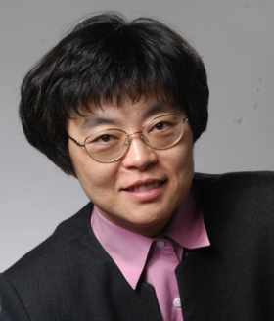
Connie Chang-Hasnain is Associate Dean for Strategic Alliances of College of Engineering and Whinnery Distinguished Chair Professor in Electrical Engineering and Computer Sciences at the University of California, Berkeley. She has been the Founding Co-Director of Tsinghua-Berkeley Shenzhen Institute since 2015. She is also the Chief Academic Officer of Berkeley Education Alliance for Research in Singapore (BEARS) since April 2015. Prior to joining the Berkeley faculty, Dr. Chang-Hasnain was a member of the technical staff at Bellcore (1987–1992) and Assistant Professor of Electrical Engineering at Stanford University (1992–1995).

Professor Chang-Hasnain has been honored with many awards including the UNESCO Medal For the Development of Nanoscience and Nanotechnologies (2015), IEEE David Sarnoff Award (2011), the OSA Nick Holonyak Jr. Award (2007), etc. Additionally, she has been awarded with a Vannevar Bush Faculty Fellowship by the US Department of Defense (2008), a Humboldt Research Award (2009), and a Guggenheim Fellowship (2009). She was a member of the USAF Scientific Advisory Board, the IEEE LEOS Board of Governors, OSA Board of Directors, and the Board on Assessment of NIST Programs, National Research Council. She was the Editor-in-Chief of Journal of Lightwave Technology 2007-2012. Professor Chang-Hasnain is a fellow of IEEE, OSA and member of the National Academy of Engineering.

